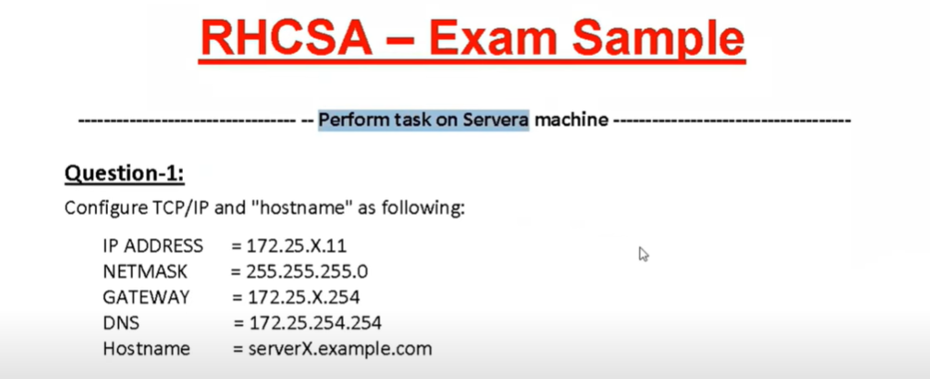

#nmtui ;use nmtui for graphically
#nmcli connection show
#nmcli device status ; red 3 line are optional
#nmcli connection delete ens160
#nmcli connection add con-name LAN1 type ethernet ifnaame ens160
#nmcli connection modify ens160/LAN1 ipv4.method manual ipv4.address 172.25.X.11/24 ipv4.gateway 172.25.X.245 ipv4.dns 172.25.254.254 connection.autoconnect yes
#systemctl restart NetworkManager
# vim /etc/NetworkManager/system-connections/ens160.nmconnection
#ifconfig | grep inet
#ip route
# cat /etc/resolv.conf
#hostnamectl set-hostname serverx.example.com
#bash
#hostname
#cat /etc/hostname
After slove the question 1, allow root user to login with SSH. And login the hosta to using SSH.
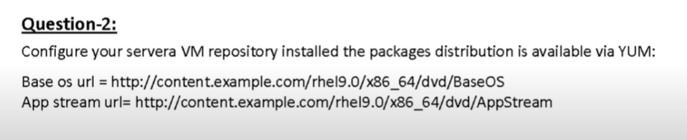

#vim /etc/yum.repos.d/pkg.repo ; here u use any name
[Base]
name=Base os
baseurl=http://content.example.com/rhel9.0/x86_64/dvd/BaseOS
enabled=1
gpgcheck=0

[App]
name=App strean
baseurl=http://content.example.com/rhel9.0/x86_64/dvd/AppStream
enabled=1
gpgcheck=0

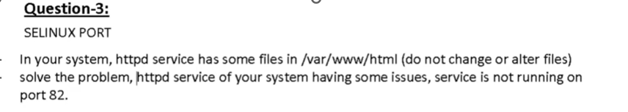
#sestatus/ getenforce if not set enforcing
#vim /etc/selinux/config after change
#fixfile -F onboot OR #touch /.autorelabel
#systemctl status httpd
#grep sealert /var/log/messages OR
#journalctl -b 0 ; here u found the error, in exam we don't use the both command
Search /SELinux is preventing
#semanage port -l | grep http
#man semanage-port ; go down, here you can found a format to allow custom port in SELinux for http
#semanage port -a -t http_port_t -p tcp 82
#semanage port -l | grep http
#systemctl restart httpd
#curl localhost:82

Allow 82 port in firewall for outside
#firewall-cmd --add-port=82/tcp --permanent
#firewall-cmd --reload
#firewall-cmd --list-all
#curl http://192.168.122.130:82

Another Question of http and SELinux
Install the httpd services and ensure that is start automatically at reboot and run port 82 using the /web as the Document root
#cd /
#ls
#mkdir /web
#touch /web/index.html

#ls -lZd /web
# ls -lZ /web/index.html

# vim /etc/httpd/conf/httpd.conf ; edit and change path
# chcon -t httpd_sys_content_t /web
# chcon -t httpd_sys_content_t /web/*
OR
# chcon -t httpd_sys_content_t /web/index.html
# systemctl restart httpd
# systemctl enable httpd
# curl localhost:82

Allow 82 port in firewall

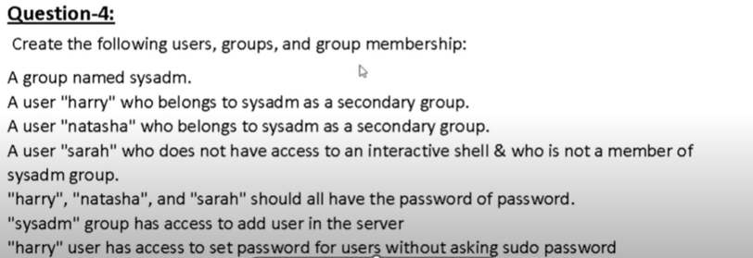
#getent group sysadm
OR
#cat /etc/group | grep sysadm
#groupadd sysadm
#useradd -G sysadm harry
#useradd -G sysadm natasha
#useraddd -s /sbin/nologin sarah
#tail -5 /etc/passwd
#tail -5/etc/shadow
#echo password | passwd --stdin harry
#echo password | passwd --stdin natasha
#echo password | passwd --stdin sarah
OR
#passwd --stdin harry
#tail -5 /etc/shadow

#which useradd
/usr/sbin/useradd
#vim /etc/sudoers or visudo

## Allows people in group wheel to run all commands
%wheel ALL=(ALL) ALL
%sysadm ALL=/usr/sbin/useradd add this line
Save + Exit

#which passwd
/usr/bin/passwd
## Allows people in group wheel to run all commands
%wheel ALL=(ALL) ALL
harry ALL=(ALL) NOPASSWD: /usr/bin/passwd
Save + Exit
Optional
harry ALL=ALL if harry full permission
harry ALL=(ALL) NOPASSWD: ALL full permission with password
Another Question: A group name is “elite” they have to give administration permission without password
Another Question:: Assing sudo privillage for group “admin” and group member can administrate with any password
%admin ALL=(ALL) NOPASSWORD:ALL
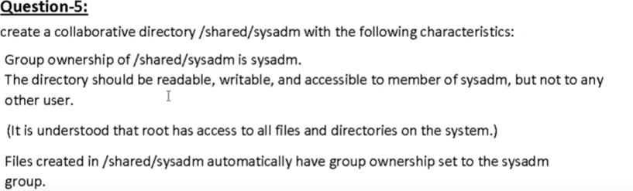
#mkdir /shared/sysadm -p
#ls -ld /shared/sysadm/
#chgrp sysadm /shared/sysadm/
#chmod 770 /shared/sysadm/ #chmod 2770 /shared/sysadm/ ; if run this
#chmod g+s /shared/sysadm/ no need to run this
#ls -ld /shared/sysadm/
#cd /shared/sysadm/
# touch root_file1
#ll

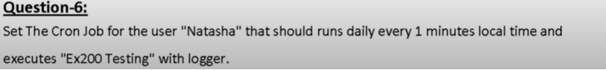

# dnf search cron
#dnf install cronie
# systemctl status crond
#crontab -u natasha -l
#crontab -u natasha -e
*/1 * * * * Loger “Ex200 Testing”

#systemctl restart crond
#crontab -l -u natasha

Schedule a task that run the command touch /etc/motd every day from Monday through Friday at 2 a.m
#vim /etc/crontab ; show crontab format
# crontab -e ; for current user
0 2 * * Mon-Fri touch /etc/motd

Save and Exit
Optional
# crontab -e ; for rechake
#0 2 * * Mon-Fri touch /etc/motd ; Add hash
*/1 * * * Mon-Fri echo “this is test file” >>/root/test11.txt ; new

Save and Exit
#ls /root
#cat /root/test11.txt ; after check ok, please off this and enable 1st schedule

Another two example of cron job
The user natasha must configure a cron job that runs daily at 13:30 local time and executes /bin/echo hello
#cromtab -u natasha -e
30 13 * * * /bin/echo hello

The user natasha must configure a cron job that runs daily at every 3-minute local time executes /bin/echo hiya
#cromtab -u natasha -e
*/3 * * * * /bin/echo hiya

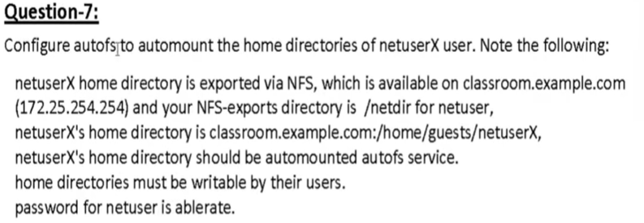

#su – remoteuser15
#df -h

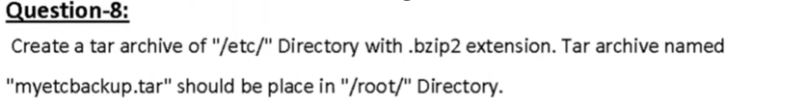
#cd /root
#tar –help ; here: j=bz2, J=xz, z=gz
#tar -cvjf myetcbackup.tar.bz2 /etc
#ll
#tar -tf myetcbackup.tar.bz2
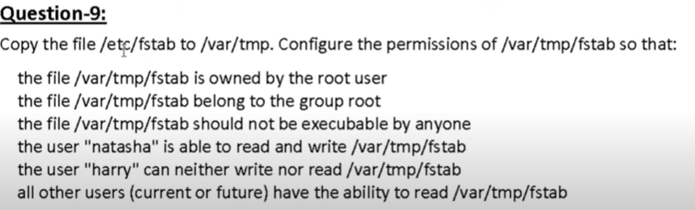
#cp /etc/fstab /var/tmp/
#cd /var/tmp
#ll
#setfacl -m u:natasha:rw- fstab
#setfacl -m u:harry:--- fstab
#getfacl fstab

Question-10
Configure your system to synchronize the time from “classroom.example.com”
#dnf search chrony
#dnf install chrony -y
#systemctl list-unit-files | grep chrony
# systemctl status chronyd
# systemctl enable –now chronyd #cd /etc/ #cp chrony.con chrony.con.bk
#vim /etc/chrony.conf
server classroom.example.com iburst
#systemctl restart chronyd
#systemctl enable chronyd ; after restart, recommanded to enabe
# chronyc sources -v
OR
# systemctl status chronyd

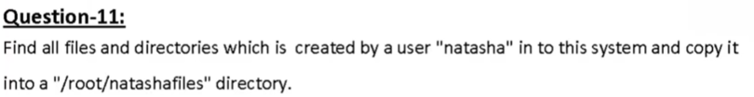
#mkdir /root/natashafiles -p
#find / -user natasha -type f -exec cp -rvf {} /root/natashafiles/ \;

Optional for acknowlage
#find / -user natasha -type f ; for show all file
#find / -user natasha -type f -print
#find / -user natasha -type f -print 2> /dev/null ; show all file without error
#find / -user natasha -type f -exec cp -rvf {} /root/natashafiles/ \; 2> /dev/null
#ls /root/natashafiles

Anothr question: Find the files in your system which is onwed by simone user and copy all the files on /root/found directory

Anothr question: locate all file owned by user ira and copy in under /root/locatefils

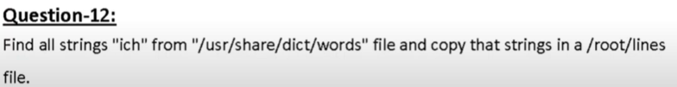
# grep "ich" /usr/share/dict/words | wc -l
# grep "ich" /usr/share/dict/words > /root/lines
# cat /root/lines | wc -l
Another Question: find the string strato from /usr/share/dict/words/file and save the result in /searchfile

#useradd -u 2334 unilao
#echo ablerate | passwd --stdin unilao
# id unilao

Another question: User of Specific UID
Create a user barry User id of this user should be 2112 ans set password atenorth

Another question: Create user ‘alex’ with 3456 uid and set password to “centtered”

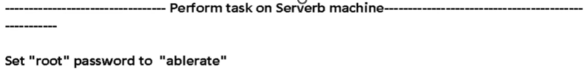

restart the machine
up arrow/down arrow
press: e

rd.break

#mount -o remount,rw /sysroot
#chroot /sysroot
#echo ablerate | passwd -stdin root
#touch /.autorelabel
#ls -la /
#exit
#exit

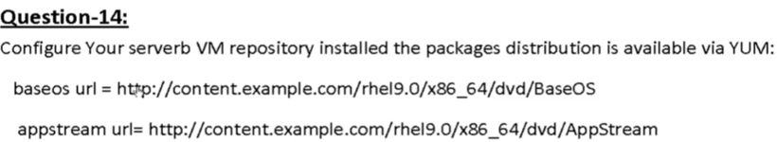

#vim /etc/yum.repos.d/pkg.repo ; here u use any name
[Base]
name=Baseos
baseurl=http://content.example.com/rhel9.0/x86_64/dvd/BaseOS
enable=1
gpgcheck=0

[App]
name=Appstrean
baseurl=http://content.example.com/rhel9.0/x86_64/dvd/AppStream
enable=1
gpgcheck=0

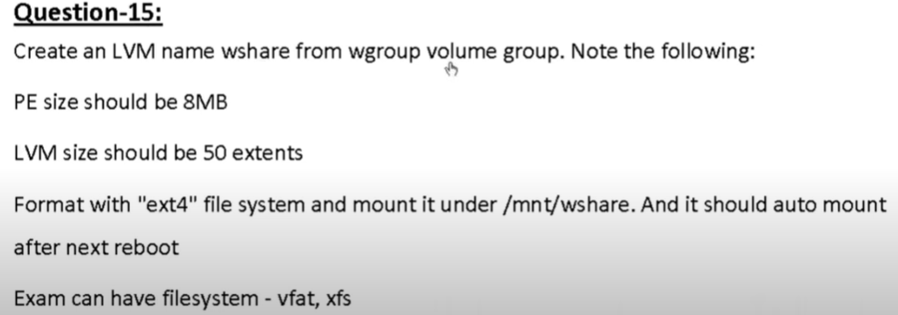

Disk size calculate for LVM
(50*8)+(8-1)
400+7
407M

Step-0: Create LVM Pertation
#lsblk
# fdisk /dev/nvme0n2
m help
n new
+1G
t change type
L list
30 for LVM
p print
w write

#partprobe /dev/nvme0n2
# fdisk /dev/nvme0n2 -l

Step-1: - PV Create
#lsblk -l
#pvs
#pvcreate /dev/nvme0n2
#pvdisplay

Step-2: - VG Create
#vgs
#vgcreate –help here -s for physicalextentsize Size
#vgcreate wgroup -s 8M /dev/nvme0n2
#vgdisplay

Step-3: LV Create
#lvs
#lvcreate –help here, -l for extents Number
#lvcreate --name wshare -l 50 wgroup
#lvdisplay

Step-4: Update partition ; optional
#partprobe /dev/nvme0n2

Step-5: formatting
# lsblk -f
#mkfs.ext4 /dev/mapper/wgroup-wshare

Step-6: Directory Create
# mkdir /mnt/wshare

Step-7: Mount Directory
#df -h
#mount /dev/mapper/wgroup-wshare /mnt/wshare/
#df -h

Step-8: fstab entry
#blkid OR blkid /dev/mapper/wgroup-wshare
#vim /ect/fstab

UUID=a907e256-7d91-4a11-8567-8a2e80296197 /mnt/wshare ext4 defaults 0 0
#mount -a
#swapon -s
#free -h
# fdisk /dev/nvme0n2
m
n
+400M
t
L
19
p
w
# fdisk /dev/nvme0n2 -l
#partprobe /dev/nvme0n2
#mkswap /dev/nvme0n2p2
#swapon /dev/nvme0n2p2
#free -h
#swapon -s
#blkid /dev/nvme0n2p2
#vim /etc/fstab
UUID=65fd0323-f849-4a80-b367-2c44ce786003 swap swap defaults 0 0
#mount -a

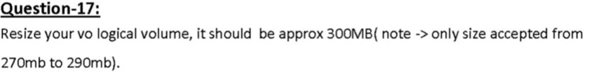
#df -h
#umount /mnt/wshare
#lvreduce -r -L 300M /dev/wgroup/wshare
#lvdisplay
#mount /dev/mapper/wgroup-wshare /mnt/wshare/
#df -h

Question-18
Configure recommended tuned profile
#dnf search tuned
#dnf install tuned
#systemctl status tuned
#systemctl is-enabled tuned
#tuned-adm profile
#tuned-adm active
#tuned-adm recommend
#tuned-adm profile virtual-guest

Question-19: Build Application
-build an application rhcsa that prints the message when logged in as ablerate user
“welcome to user ablerate”
#vim /usr/local/bin/rhcsa

#!/bin/bash
echo "Welcome to user ablerate"
Save and Exit
#vim /home/ablerate/.bashrc

Here After
fi
/usr/local/bin/rhcsa
save and exit
Note: also same entry the .bashrc_profile
#ls -l /usr/local/bin/rhcsa
#chmon 755 /usr/local/bin/rhcsa
#su aberate

Another Question: Build Application
-build an application testapp that prints the user1 logged in
“welcome to user1”


Question-20 (There is no need to answer separately)
#vim Containerfile
FROM docker.io/centos/httpd-24-centos7
Save and Exit
#ls
#podman build . -t myimage:v1
#podman images
localhost/myimage v1 5ae4c76f6a3e 3 years ago 361 MB
docker.io/centos/httpd-24-centos7 latest 5ae4c76f6a3e 3 years ago 361 MB

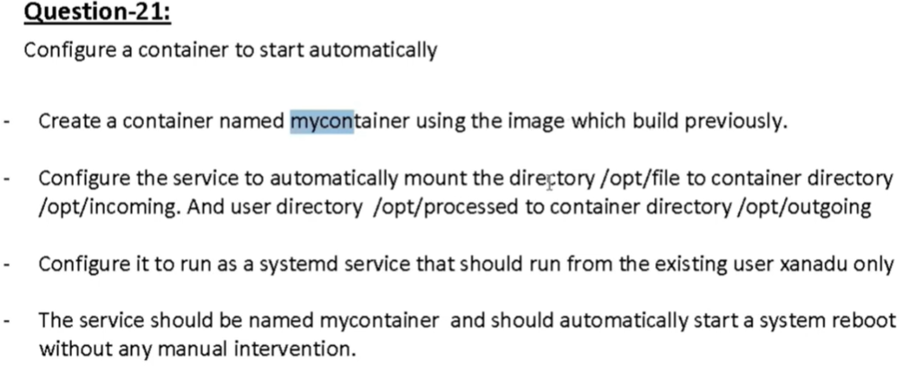
Question-21
#useradd xanadu
#echo xanadu | passwd –stdin Xanadu
#ssh xanadu@localhost
$podman login Login_URL (Important file a thakba)
Username:
Password:
$mkdir mycontainer
$ls
$cd mycontainer/
$wget URL
OR
$vim Containerfile
FROM docker.io/centos/httpd-24-centos7
Save and Exit

$ls
$podman image build . -t myimage
$podman images
$exit

#mkdir /opt/file
#mkdir /opt/processed
#touch /opt/file/1
#touch /opt/processed/1
#chown xanadu:xanadu /opt/file
#chown xanadu:xanadu /opt/processed

#ssh xanadu@localhost
$cd mycontainer/
$ls
$podman images
$podman run -d --name mycontainer -v /opt/file/:/opt/incoming:Z -v /opt/processed/:/opt/outgoing:Z localhost/myimage:v1
$podman ps
$podman ps -a

$loginctl show-user xanadu
$loginctl enable-linger xanadu
$loginctl show-user xanadu
$pwd
$ls -la
$cd ..
$pwd
$ls -la
$mkdir -p ~/.config/systemd/user
$cd ~/.config/systemd/user/

$podman generate systemd --name mycontainer –files –new
OR
$podman generate systemd --name mycontainer -f -n
$ls
$cat container-mycontainer.service
$podman ps
$podman stop mycontainer
$podman rm mycontainer
$systemctl --user daemon-reload
$ls
$podman ps

$systemctl --user enable --now container-mycontainer.service
$systemctl --user status container-mycontainer.service
$podman ps
$podman exec -it mycontainer bash
$ cd /opt/incoming/
$ls

$systemctl --user stop container-mycontainer.service
$podman ps

$systemctl --user start container-mycontainer.service
$podman ps
$exit
#reboot

#ssh xanadu@localhost
$cd mycontainer/
$podman ps
$exit

Extra question
Question-X:
Set the permission
- All new creating files for user natasha as r-- --- --- as defaults permission
- All new creating directory for user natasha as dr-x --- --- as default permission

#echo "umask 0277" >>/home/natasha/.bashrc
#su natasha
#umask
#cd /home/natasha
#touch 1
#mkdir 2
#ll

Another question: Set the default permissions for user alex for all newly created files and folders
- Set permissions to the all newly created files r--r--r--
- Set permissions to the all newly created directory r-x r-x r-x

Question-X: password expire after 30 days for newly created user
# vim /etc/login.defs ; edit the file

#useradd jamal
#echo 123 | passwd –stdin jamal
#chage -l jamal

Configure the rhcsa application so that when run as "pandora" it shows below message "Labla Ibal lahs ksbhs".

#vim /usr/local/bin/rhcsa
#!/bin/bash
if [ "$(whoami)" == "pandora" ]; then
echo "Labla Ibal lahs ksbhs"
else
echo "You are not authorized to run this application."
Fi

Ro rw init=/bin/bash
Ctl+x

Passwd root

#touch /.autorelabel
#exec /sbin/init

